**Application#:**

**Flight Ticket Booking**

1. **User Interface Test Screens**
   1. Listing of users
   2. Searching a user
   3. Clicking on One User in the list
   4. Viewing the details of selected user in the list. User can navigate to next user in the list or navigate to back to list
   5. Editing user details
   6. Creating a new user
2. **Validations in User Interface Test Screens**
   1. Required field validations
3. **Verify the Web Service Test Screens**
   1. When we run the .Net Web API, with the given UR (<https://localhost:44371/api/users>)L, below is the data displayed.
4. **User Interface Test Screens**
   1. **Login Screen**

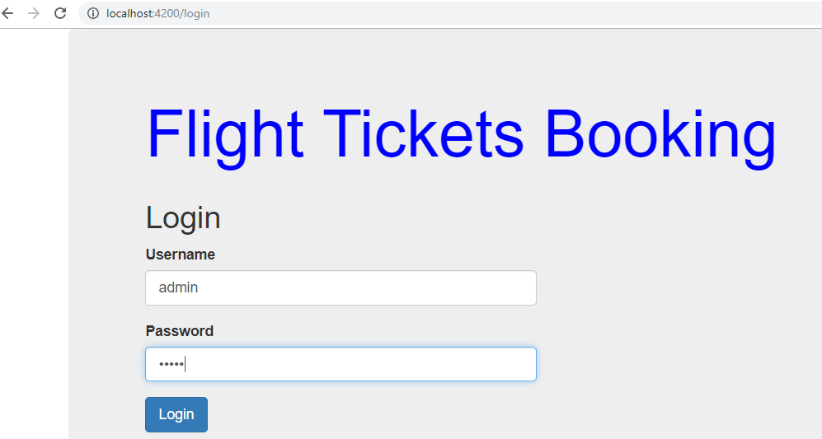

* 1. **Listing of users**

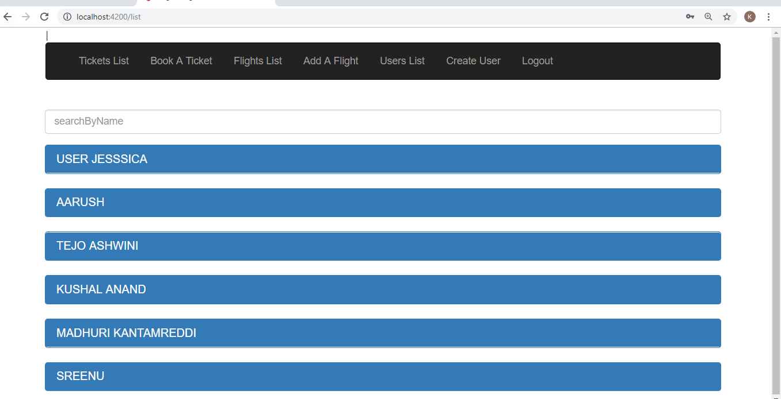

* 1. **Searching a user**

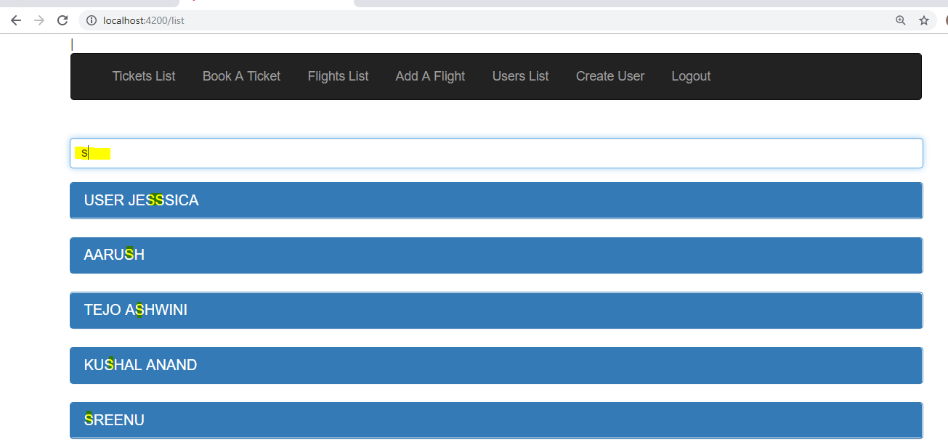

* 1. **Clicking on One User in the list**

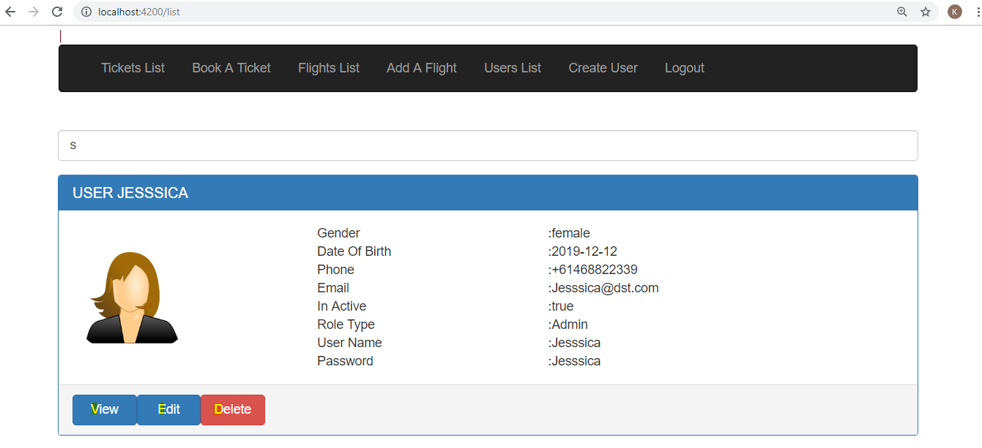

* 1. **Viewing the details of selected user in the list. User can navigate to next user in the list or navigate to back to list.**

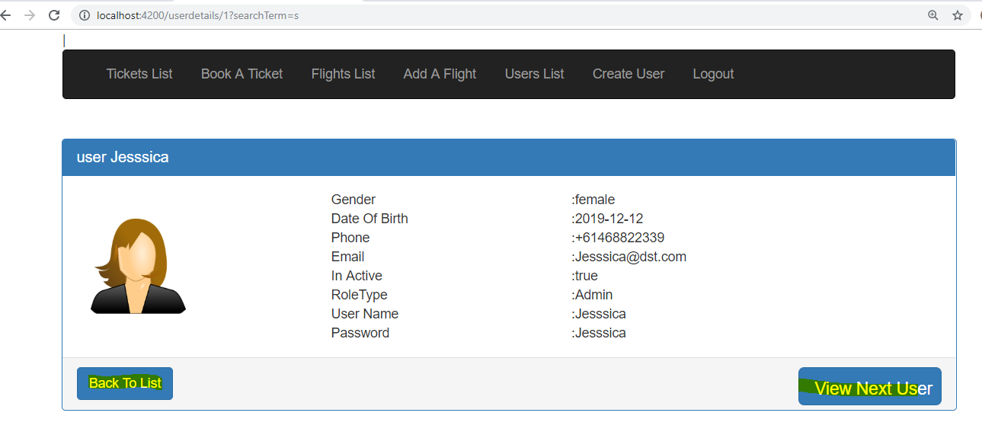

* 1. **Editing user details**

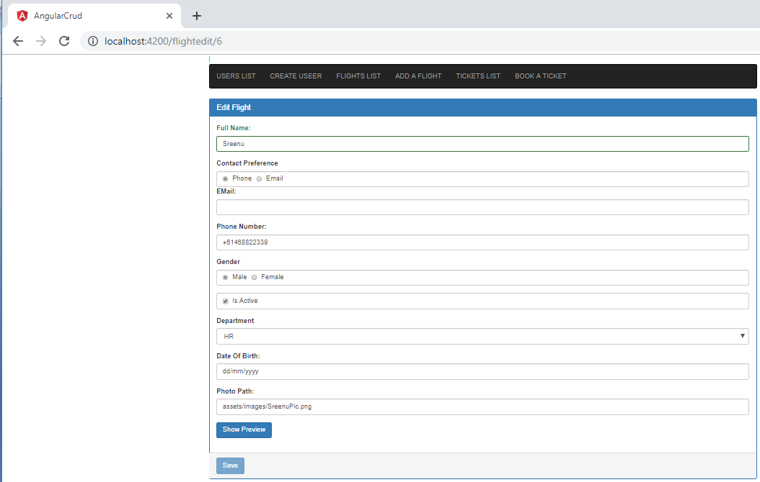

* 1. **Creating a new user**

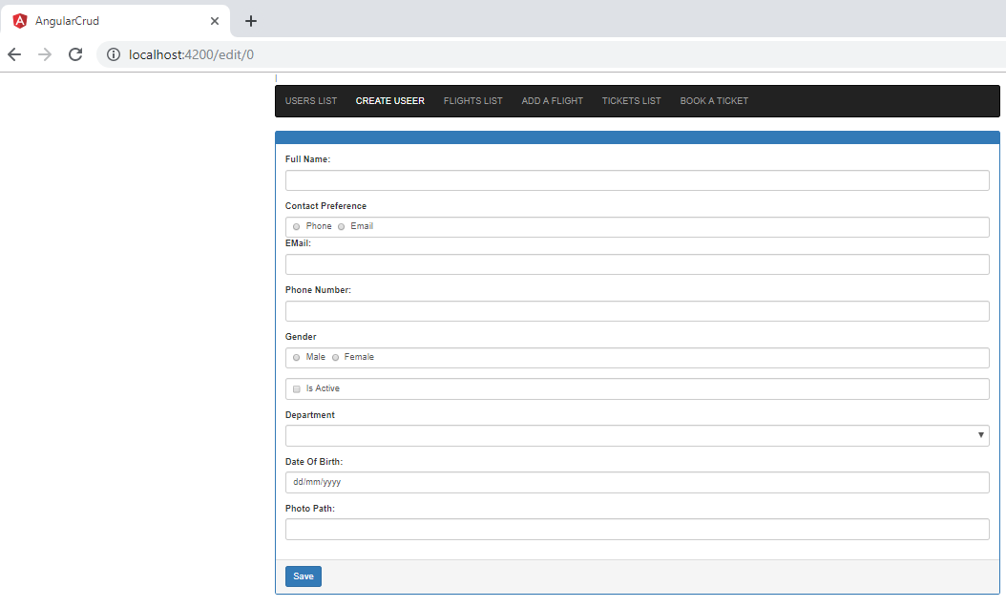

1. **Validations in User Interface Test Screens**
   1. Required filed validations

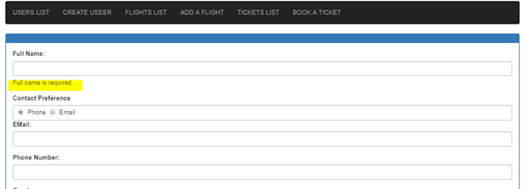

1. **Verify the .Net Web API Test Screens**
   1. When we run the .Net Web API, with the given UR (<https://localhost:44329/api/userdetails>) as shown below for userdetails.

[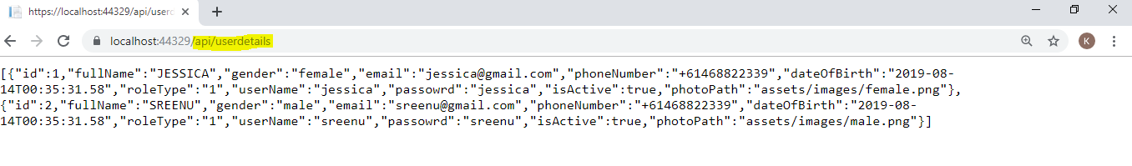](https://localhost:44329/api/flights#)

* 1. When we run the .Net Web API, with the given UR (https://localhost:44329/api/flights) as shown below for flights.

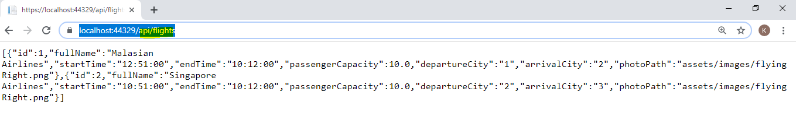

* 1. When we run the .Net Web API, with the given UR (<https://localhost:44329/api/tickets>) as shown below for tickets.

